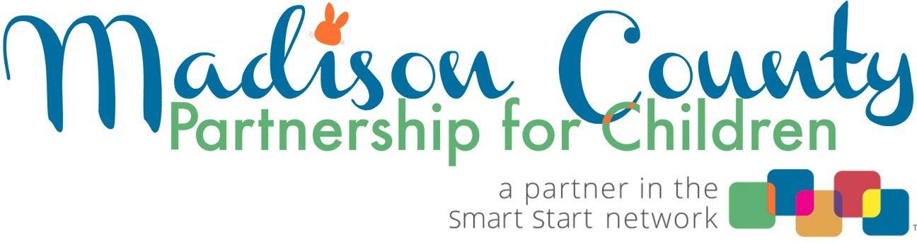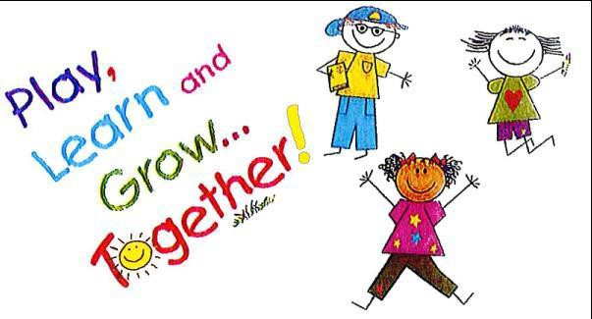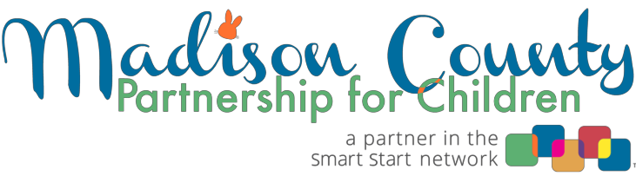
Who funds the Kith & Kin Play and Learn Groups?

Kith & Kin Play and Learn Groups are funded by the Madison County Partnership for Children and Families (Smart Start) and private donations. The Partnership has contracted with the Madison County Health Department to operate the program. The Kith & Kin program coordinator's office is housed at the Health Department.

Does Kith & Kin have a Facebook page?

Yes! Please LIKE us at Kith and Kin Play Days Madison County, NC. Schedules, updates, and other useful early childhood information is posted there regularly.

What is the contact information for the
Kith & Kin Play and Learn Group coordinator?
You can contact Rosie Eisenberg, Ed.S. at: reisenberg@madisoncountync.gov or
828-713-1787

Welcome to Supporting Family Choices:
Kith & Kin
Play and Learn Groups

I
As a caregiver, I love to sing and read with children.
Can I lead something during Circle Time?
The Kith & Kin coordinator and the children love it when caregivers choose to share their gifts of music and/or reading with the children. If you would like to lead songs, play an inst r ument, or read a story to the children during Circle Time, please do! The coordinator will be happy to schedule a day and time that works for you!
I heard that my child receives a free book each month. Is
that true?
Kith & Kin has been fortunate to receive donated funds to
purchase books for children to take home for free on a monthly basis. As long as the funds are available, the answer is yes. The coordinator has early literacy information to help caregivers learn about ways to promote reading with their child(ren) in the home.

Welcome to Supporting Family Choices:
Kith & Kin
Play and Learn Groups
What does Kith & Kin mean?
Kith means friends and neighbors.
Kin means family.

Why is the program called usupporting Family Choices: Kith & Kin Care"?

The part of the name, Supporting Family Choices , refers to the program being designed for those families who choose to not enroll t he_ir childr en full time in child care by providing another type of
learning exper ience: Play and Learn Gr oups. Kith & Kin Care means the children enrolled are cared for by a family member, fr iend, or neighbor, OR, in short, Kith & Kin. Kith & Kin Play and Learn Groups are attended by mothers, fathers, grandmothers, and any family member, friend or neighbor who is responsible for the daytime care and nurturing of young childr en. Many families choose to opt out of pre-school or child care and this program is available for t hem.

Will photos be taken of my child?

Every family is asked to complete a Consent to Observe/Record form whereby you, as caregiver, can agr ee, or disagree, to have you or your child's photo t aken. Kith & Kin (of Madison County) has a Facebook page and occasionally the coordinator will take a picture to use on the FB page or perhaps in a PowerPoint presentation to promote the program. Our funder, the Madison County Partnership for Children and Families, also uses (unidentified) photos in promotional materials
and pr esentat ions. If you are not comfortable with having your child's
photo taken, please inform the coor dinator .

What is the winter weather policy?

If schools are closed due to inclement weather, Kith and Kin is cancelled. If schools open on a 2 hour delay, WE WILL MEET. If there is a 3 hour delay, Kith and Kin will be cancelled. You can sign up for text alerts to be sent to your phone by going to the WLOS.com website and signing up for Madison County schools.
•••••••••••••••••• ••••••••••••••••••

How do I enroll?

The groups require advance registration, rather than drop-in. It is best to contact the coordinator by phone or through email to register.

Does my child have to be up-to-date on vaccinations to attend?

Vaccinations are highly recommended. Each family will receive a let­ ter, along with the Kith and Kin handbook, stating the important rea­ sons behind child immunizations. In the case of a county outbreak of a communicable disease such as chicken pox, etc., the families with unvaccinated children will be asked to not attend play groups until the Health Department receives an "all clear" status.

Does Kith & Kin Play and Learn groups have a policy regarding children who are sick?

Yes! Please keep your child(ren) at home if they have :
- Fever; oral temperature above 101 degrees / rectal temperature above 102 degrees/ axillary (under arm) temperature above 100 degrees
- Persistent diarrhea
- Conjunctivitis, which is an eye infection commonly referred to as "pink eye"
- Undiagnosed rash, except diaper rash
- Vomiting two or more times in previous 24 hour period, or any vomiting accompanied by other signs of illness
- Jaundice (yellow) skin or eyes
- Difficult or rapid breathing
- Symptoms of strep throat or chicken pox

What are Kith & Kin Play and Learn Groups?

Kith & Kin Play and Learn Groups are informal neighborhood gatherings for children birth through five years of age who are not enrolled full-time in regulated childcare. The groups offer developmentally-and age-appropriate activities for the children. Some of the activities include block play, drawing and painting, play-doh, puzzles, games, music, singing, and more. The Play and Learn activity centers are flexible and in an environment where the child's natural desire to learn is stimulated through meaningful, appropriate, and playful learning experiences that meet the needs of each child as an individual.

The Play and Learn Groups facilitate the optimum social, emotional, intellectual, and physical development of each child by being aware of the various stages of development, and by providing arpropriate learning experiences. Play is recognized as the natura vehicle by which a child learns. It is through play that the child exercises curiosity and imagination, learns to concentrate, tries new ideas, and practices grown-up behavior. The value of play cannot be overstated. Play creates opportunities for children to make choices, enhance their self-esteem, encourage their independence, and develop a sense of responsibility for his or her own actions.

While the Play and Learn groups have many goals, a major one is to help children learn to socialize with other children in their same age range prior to entering kindergarten.

During the groups, the coordinator will also conduct informal observations of children to assist caregivers in recognizing any delays or developmental concerns, and to help with referrals. The coordinator makes herself available for one-on-one discussions of any needs or issues, depending on individual circumstances.

The Play and Learn groups provide educational resources for caregivers [the adults who care for the child(ren)].

- Head Lice, scabies, or other parasitic infections

•••••••••••••••••• ••••••••••••••••••

What do I need to bring to a Kith & Kin Play and Learn Group?

Simple crackers are provided for the children. Please bring a drink
for your child. The preference is for you to provide water or milk. You may also bring a snack for your child if you choose. Please DO NOT bring any snacks that include peanuts, due to some children's
all ergies.

Who leads the Play and Learn Groups?

The groups are led by a coordinator, with a background in Early Childhood Education, who guides the children and adults through activities focused on developing early learning skills in the areas of language development, social-emotional development, intellectual development, and motor (muscle) development . The coordinator also informs caregivers on topics such as learning through play, behavior expectations, early literacy, health and safety, community resources, and mor e.

What is the Circle Time portion of the Play and Learn Groups?

The coordinator always informs the children approximately 3 to 5 minutes before it is time to start cleaning up the toys (transition t ime). Everyone works together to sort the toys into the proper
baskets and clear the space. Then everyone joins in a large circle and the singing begins!

What is expected of the caregivers during Circle Time?

Circle Time is a great time for caregivers to model appropriate behavior for children during a group act ivit y. When caregivers sit and listen to the group leader, the children learn to do the same. Singing is important for many r easons: children love it ; it's a social act ivit y; children learn memorization skills, rhyming (which helps with pre­ reading), counting, movement, predictability, and more!

••••••••••••••••••

Where are the Kith & Kin Play and Learn Groups held?
Locations include the public libraries and community centers that are embedded in local communit ies. Groups may meet in the morning or the afternoon, depending on the availability of the site and the demand of the caregivers. Schedules and locations can be found on the fliers or by calling the coor dinator . Schedules occasionally change as children age-out or relocate and new families become involved .

How often do the groups meet and for how long?

Groups meet weekly for an hour and a half each session.

Do I have to stay with my child(ren) when they are at the Play & Learn Groups?

Yes. The primary goal of the program is to help caregivers understand how children learn through play so they can support early literacy and school readiness skills through every day activities in the home environment . Every day activities are natural learning opportunities that are demonstrated during Play and Learn groups with the goal of taking the knowledge and information into the home.
Caregivers also find themselves creating supportive relationships with other car egivers. Caregivers exchange community information and resources with one another and often create opportunities for children to play and learn together outside of the gr oups.

How much will I have to pay to participate in Kith & Kin Play and Learn Groups?

The Play Groups are FREE for Madison County r esidents. Remember, your child(ren) has to be between the ages of birth through five years of age, not enrolled full time in child care and has not started kindergarten yet.

••••••••••••••••••

